SOLAR COOKER:
Solar cooker is a device used to cook food by utilizing the energy radiated by the sun.
Materials required making solar cooker: wooden box, aluminium sheet, thermocol, black sheet, mirror, lid, hinges, glass sheet and containers.
Working: Take aluminium sheets and make a box which is then painted black, then fix this aluminium box inside the wooden box having thermocol lining, then fix the mirror with the lid and with the help of hinges fix the lid to the wooden box, now cover the box with the glass sheet (it helps in trapping the heat radiations), the mirror helps in concentrating light rays into the box and can be used to cook food, containers used to cook food should also be painted black. Place these containers filled with food items inside the box. After this place the solar cooker in direct sunlight, adjust the position of plane mirror so that a strong beam of sunlight falls on the glass sheets, the rays coming from the sun bounce through the glass sheet and are absorbed by the objects inside the cooker, the glass sheets does not allow the solar energy to flow out in the form of radiant heat, gradually more and more heat radiations get trapped and the food gets cooked. The range of temperature that can be attained in a solar cooker is 100-140°C.
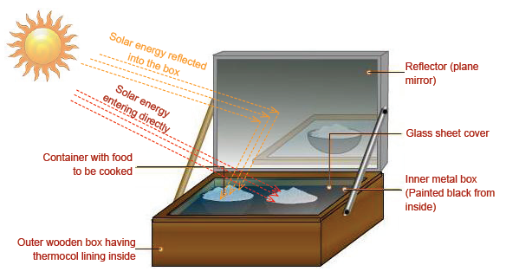
SOLAR DISTILLATION:
Solar distillation is the process of using energy from sunlight to separate freshwater from salts or other contaminants. The untreated water absorbs heat, slowly reaching high temperatures. The heat causes the water to evaporate leaving the contaminants behind.
Working:
A container should be there which is painted black from surface for absorbing the radiations. Container contains salt water which is covered with a glass plate so that the energy enclosed in this container is not lost outside. When radiations of sun fall on the glass plate then these radiations are absorbed by the water present inside the container and water start forming vapours and these vapours go upward and be in contact with the glass plate surface where they will be converted into liquid drops and we have taps on the sides of the containers for collecting liquid drops through which pure water moves outward leaving behind the contamination.
